COMMUNIQUE DE PRESSE
January 31, 2022

Review 2021/ Summer 2022

Marseille Provence Airport stay the course !

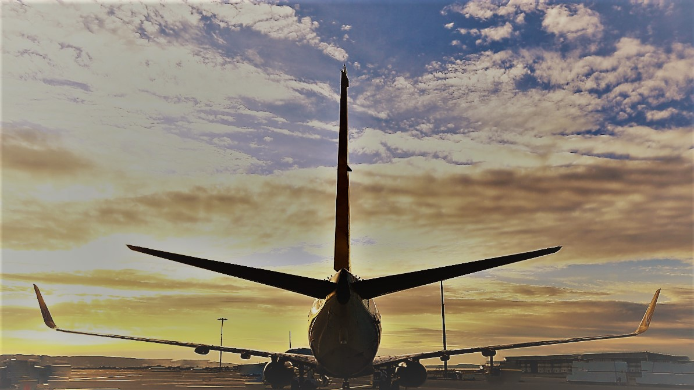

“We had estimated the year at 4.5 million passengers, we had 166,000 more, In 2022, we hope to have more. “, Philippe Bernand, CEO of Marseille Provence Airport (AMP). Overall, traffic really picked up from July to December, when we hit about 70% of 2019. On average, 2021 is almost half of 2019 traffic.
Overall, we can say that Marseille Provence airport is one of those that has done the best from a traffic point of view since the start of the pandemic, with one of the best recovery rates in France. (46% traffic compared to 2019), AMP is in 4th place among French airports,
As a reminder, the offer offered for the summer / winter seasons corresponded to around 80% of the 2019 offer. During these periods, AMP welcomed 3 new companies: Air Arabia, Corsair and Binter, the last two of which operate with latest generation aircraft (A330 Neo and Embraer E195-E2).
We had to juggle border openings and closings based on health restrictions. For these reasons, we have constantly found solutions to adapt: ​​by creating, at the height of demand, up to 5 covid test laboratories in the airport (two at arrivals, and three at departures), with PCR results available in less than two hours, to make life easier for passengers.
This year will also have been marked by a phase of renewal, a resumption of responsibility, with the launch of work on the "Airport Heart" intended to improve our operational efficiency and upgrade our quality standards, the commissioning of our new hot/cold plant to drastically reduce our consumption and our carbon emissions and the launch of many other virtuous projects which should enable us by 2030 to be self-sufficient in energy and therefore more virtuous.
It is with this in mind that we are preparing to welcome, for the 2022 summer season, an offer almost identical to the last summer season to 29 countries around the world with 4 new destinations Antalya, Funchal, Vienna, and Mauritius and 16 new routes. (Antalya with Sun Express / Berlin, Funchal, Lanzarote, Luxembourg, Tel Aviv, Tenerife, Venice and Vienna with Ryanair / Mauritius with Corsair / Lille and Rennes with Transavia, Toulouse with TwinJet, Oran with Volotea, Ibiza with Iberia, Heraklion with Sky Express). A new company also: Sky Express, which will complete our program on Crete, with the latest generation A 320 Neo aircraft. We are also pleased to be able to announce the resumption of flights to Montreal with Air Transat.
Finally, in 2022, AMP will celebrate its 100th anniversary! An anniversary that will be celebrated with numerous events throughout the year, until October. The opportunity to retrace the path traveled by the platform, but beyond, throughout the territory. 2022 will allow us to take stock of a century of air travel in order to look towards a resolutely more virtuous future.

CHIFFRES CLéS
- 4, 66 millions passengers in 2021 (-54,1 % vs 2019 / + 38,8 % vs 2020)
- 2nd régional airport in passengers traffic, first in express freight
- Summer 2022 : 110 destinations to 29 countries by 138 routes
- 1 new restaurant : EXKI (Terminal 1 Hal A)
- 100 years of existence

About Marseille Provence Airport (AMP)
The Marseille Provence Airport site now includes more than 140 companies and 4,500 employees, including 360 from Marseille Provence Airport. Our ambition is to develop a virtuous airport model promoting connectivity, fully in line with the preservation, attractiveness and economic dynamism of its territory. In France, we are the 1st regional airport in express freight and the 2nd regional airport in terms of passenger traffic. The airport handled 4.66 million passengers in 2021 (10.1 million in 2019).
Press Contact
Rosalie Floutier : Rosalie.floutier@mrs.aero | 07 79 61 01 22

